# Week 1 Deliverable

**Goal:** Create a computer simulation that models the patterns observed in host-parasite coevolution

**Inputs:** # of hosts with allele A(hA), # of hosts with allele A(ha), # of Parasites who prefer allele A(pA), # of Parasites who prefer allele (pa)

**Relationships:** As hA increases, pA increases. But hA falls when pA gets too high, because the parasite population kills all the hosts. As a result, the ha population increases, which causes the pa population to increase. When the pa population gets too high, it kills most of the ha population and causes the cycle to repeat itself, creating a graph like the one below.

**Output:** A graph that resembles this one

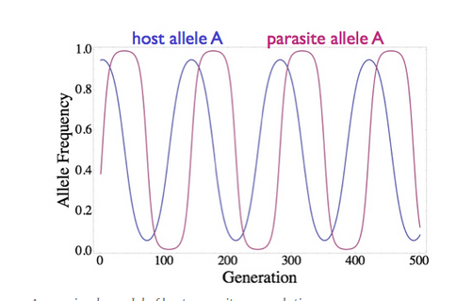

**Code:**

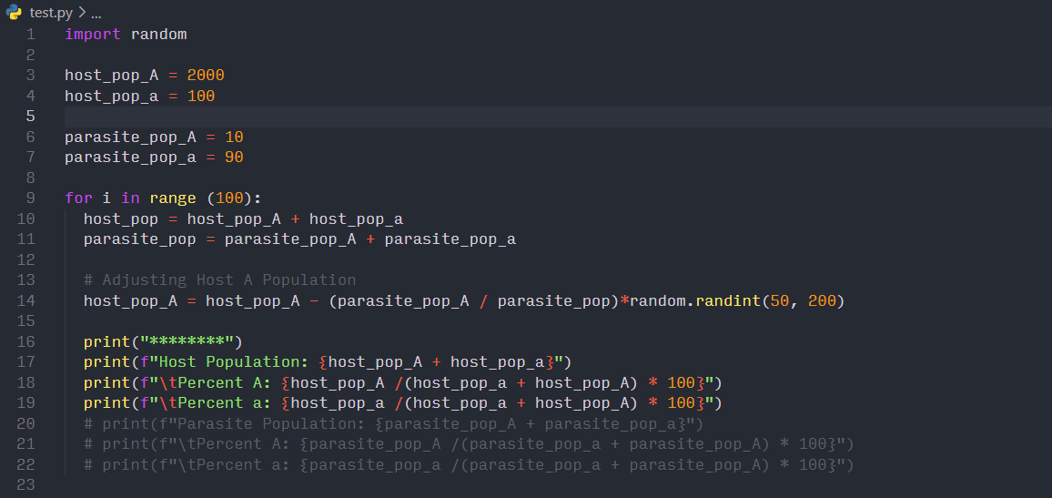

**Output:**

Generation 0

Host Population: 2092.6

Percent A: 95.22125585396158

Percent a: 4.778744146038421

********

Generation 1

Host Population: 2079.8

Percent A: 95.19184536974709

Percent a: 4.808154630252909

********

Generation 2

Host Population: 2072.8

Percent A: 95.17560787340794

Percent a: 4.824392126592049

********

Generation 3

Host Population: 2062.3

Percent A: 95.1510449498133

Percent a: 4.848955050186684

********

Generation 4

Host Population: 2055.7

Percent A: 95.13547696648345

Percent a: 4.864523033516564

********

Generation 5

Host Population: 2048.9

Percent A: 95.11933232466201

Percent a: 4.880667675337986

********

Generation 6

Host Population: 2029.7

Percent A: 95.07316352170272

Percent a: 4.926836478297285

********

Generation 7

Host Population: 2011.1000000000001

Percent A: 95.02759683755158

Percent a: 4.972403162448411

********

Generation 8

Host Population: 1999.4

Percent A: 94.99849954986496

Percent a: 5.00150045013504

********

Generation 9

Host Population: 1985.8000000000002

Percent A: 94.9642461476483

Percent a: 5.0357538523516965

********

Generation 10

Host Population: 1972.9

Percent A: 94.93131937756601

Percent a: 5.06868062243398

********

Generation 11

Host Population: 1962.2

Percent A: 94.90367954336969

Percent a: 5.096320456630313

********

Generation 12

Host Population: 1952.0

Percent A: 94.87704918032787

Percent a: 5.122950819672131

********

Generation 13

Host Population: 1937.6

Percent A: 94.83897605284889

Percent a: 5.161023947151115

********

Generation 14

Host Population: 1924.6999999999998

Percent A: 94.80438509897647

Percent a: 5.195614901023537

********

Generation 15

Host Population: 1917.1999999999998

Percent A: 94.78406008762778

Percent a: 5.215939912372209

********

Generation 16

Host Population: 1911.2999999999997

Percent A: 94.76795898079841

Percent a: 5.232041019201591

********

Generation 17

Host Population: 1897.3999999999996

Percent A: 94.7296300200274

Percent a: 5.270369979972595

********

Generation 18

Host Population: 1877.9999999999995

Percent A: 94.6751863684771

Percent a: 5.324813631522899

********

Generation 19

Host Population: 1863.6999999999996

Percent A: 94.63432955947846

Percent a: 5.365670440521544

********

Generation 20

Host Population: 1849.8999999999996

Percent A: 94.59430239472404

Percent a: 5.405697605275963

********

Generation 21

Host Population: 1840.9999999999995

Percent A: 94.56816947311243

Percent a: 5.431830526887563

********

Generation 22

Host Population: 1831.2999999999995

Percent A: 94.53939824168623

Percent a: 5.460601758313768

********

Generation 23

Host Population: 1815.3999999999994

Percent A: 94.49157210532114

Percent a: 5.508427894678861

********

Generation 24

Host Population: 1806.0999999999995

Percent A: 94.4632080172748

Percent a: 5.536791982725211